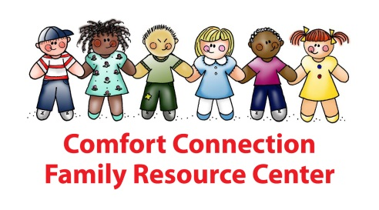
O.C. UNIVERSALLY ACCESSIBLE PARKS

- Box Canyon Park: Accessible Playground for All Pirates and Knights
23400 Foxtail Dr.
Yorba Linda, CA 92887
http://funorangecountyparks.com/2010/06/box-canyon-park-yorba-linda.html

The ship is meant for 2-5 year olds, and the castle is meant for 6-12 year olds – but there are ramps on both that make it easily accessible for everyone. Many interactive panels are built into the play structures, including music chimes, drums, and gears to spin.

- Courtney’s SandCastle: Universal Playground & Sensory Garden in San Clemente
987 Avenida Vista Hermosa
San Clemente, CA 92673
(949) 321-8264
http://courtneyssandcastle.com/

Courtney’s SandCastle Universal Playground in San Clemente is part of the Vista Hermosa Aquatics Center and Sports Park. It’s a beautiful play space with a pirate ship and a castle, where children of all abilities can play together; it also features a sensory garden including water features. Playground is completely fenced for safety purposes.

- Heritage Park: Irvine with Water Play Fountains
14301 Yale Ave.
Irvine, CA 92604
http://funorangecountyparks.com/2010/10/heritage-park-irvine.html

Easy to see the kids from most points in the park
There’s also an accessible “boat” and a ramp that fits a wheelchair. The best way to make it rock is for an adult to stand in the middle and almost do lunges back-and-forth.

- Pavion Park: Mission Viejo
24051 Pavion
Mission Viejo, CA
http://funorangecountyparks.com/2010/08/pavion-park-mission-viejo.html

Universally accessible, they integrated a little natural history with interpretive signs about animals that are (or were once) native to the area. Colorful adirondack chairs grouped for socializing.

- Pittsford Park: Trike Course on the Accessible Red Playground
21701 Pittsford Drive
Lake Forest, CA 92630
http://funorangecountyparks.com/2008/11/pittsford-park-lake-forest.html

Pittsford Park added a universally accessible playspace. It’s brilliant red with even the upper levels accessible to wheelchairs. A cars/roadway theme provides little people with stop and yield signs and a trike course.

- Playground at the Beach
913 Pacific Coast Highway
Huntington Beach
https://www.huntingtonbeachca.gov/residents/parks_facilities/parks/city-beach-playground.cfm
Can be accessed from existing pathways from parking areas and the beach path. The park is designed to be all-inclusive with the play units designed to provide accessibility and promote interactive play among children of all abilities.

- TeWinkle Park: Angel’s Playground for Expansive Accessible Fun
885 Junípero Dr.
Costa Mesa, CA 92626
(714) 754-5300
http://funorangecountyparks.com/2008/11/tewinkle-park-costa-mesa-angels-playground.html

Completely “barrier-free,” universally accessible and ADA compliant. Kids of all ages and abilities are drawn to the moving sled/car/boat , where they can travel to anywhere their imagination takes them.

